Open Elliptical Curves
# Source: AI Source: Provided by: [Data Path: Persons Table -> ID Column: 1, Name_En Column: Motasem Essam] -> From: [ChatGPT] on [7/25/2026]
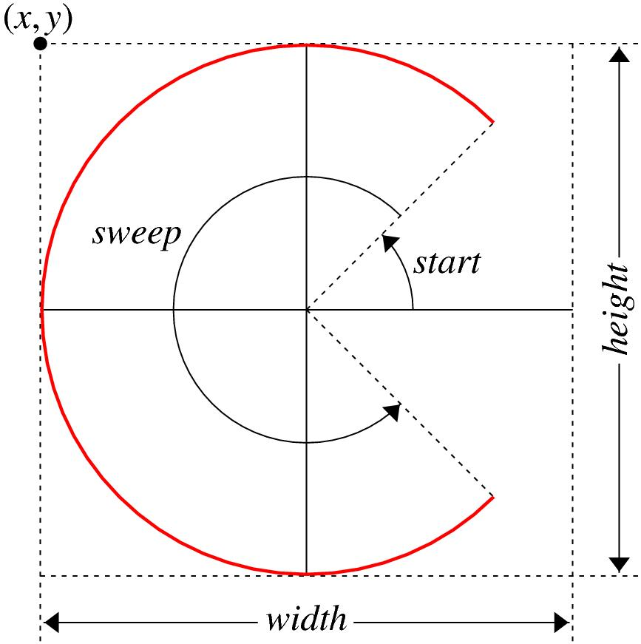
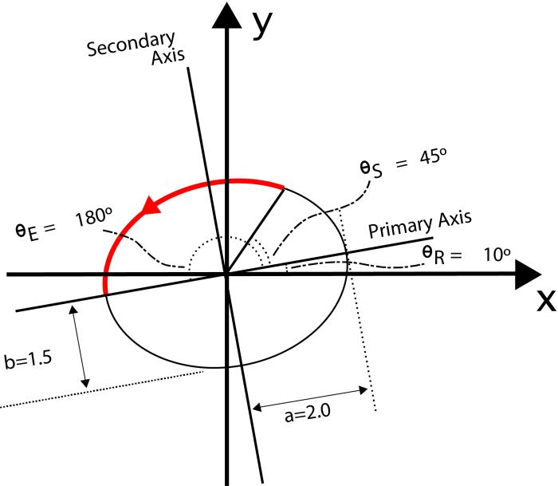
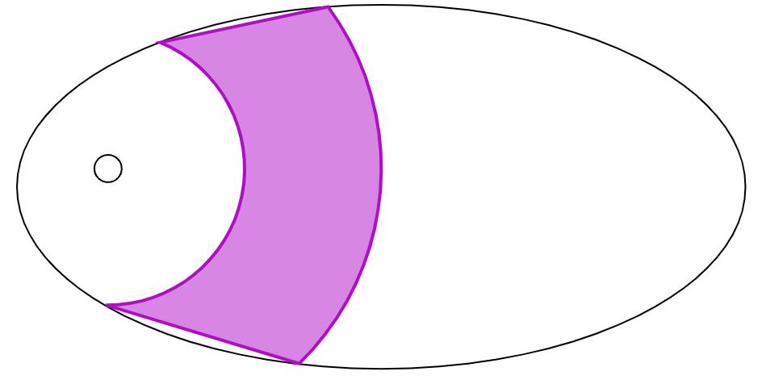
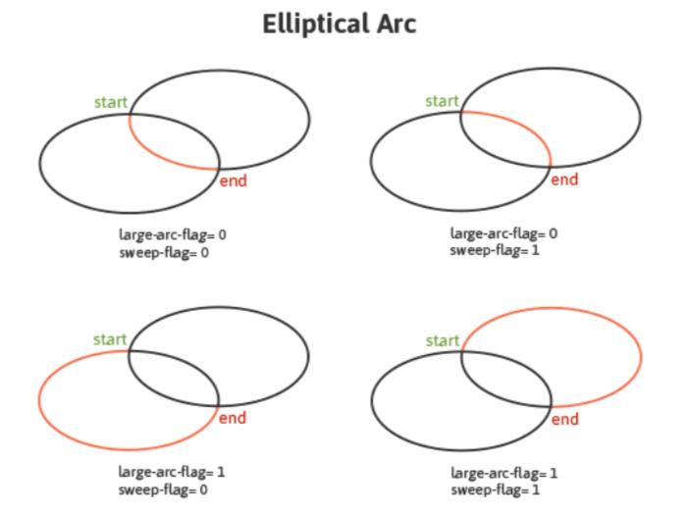
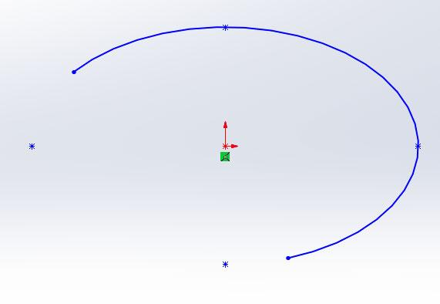

Definition
# Source: AI Source: Provided by: [Data Path: Persons Table -> ID Column: 1, Name_En Column: Motasem Essam] -> From: [ChatGPT] on [7/25/2026]
An Open Elliptical Curve is an open curved shape formed by a continuous portion of an ellipse, with two distinct endpoints that are not connected.
$$\boxed{\text{Open Elliptical Curve}=\text{Part of an Ellipse}+\text{Continuous Curvature}+\text{Two Open Endpoints}}$$
Unlike a complete ellipse, an open elliptical curve does not form a closed boundary and therefore does not enclose an area by itself.

Characteristics
# Source: AI Source: Provided by: [Data Path: Persons Table -> ID Column: 1, Name_En Column: Motasem Essam] -> From: [ChatGPT] on [7/25/2026]
An Open Elliptical Curve:
- Is open.
- Is part of an ellipse.
- Has two distinct endpoints.
- Has continuously changing curvature.
- Has a major axis and minor axis inherited from the underlying ellipse.
- Does not enclose an area by itself.
- Can be a short or long portion of an ellipse.
- Can be symmetric or asymmetric depending on the selected portion.
- Can be used as part of a larger mixed or closed shape.

Types of Open Elliptical Curves

1. Minor Elliptical Arc
# Source: AI Source: Provided by: [Data Path: Persons Table -> ID Column: 1, Name_En Column: Motasem Essam] -> From: [ChatGPT] on [7/25/2026]
A Minor Elliptical Arc is a relatively short portion of an ellipse between two endpoints.
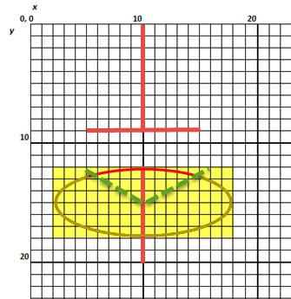
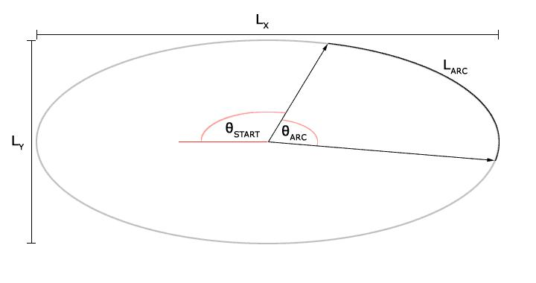
It covers only a small portion of the complete ellipse.
Unlike a circular arc, there is no simple central-angle definition for a general elliptical arc.

2. Major Elliptical Arc
# Source: AI Source: Provided by: [Data Path: Persons Table -> ID Column: 1, Name_En Column: Motasem Essam] -> From: [ChatGPT] on [7/25/2026]
A Major Elliptical Arc is a relatively long portion of an ellipse between two endpoints.
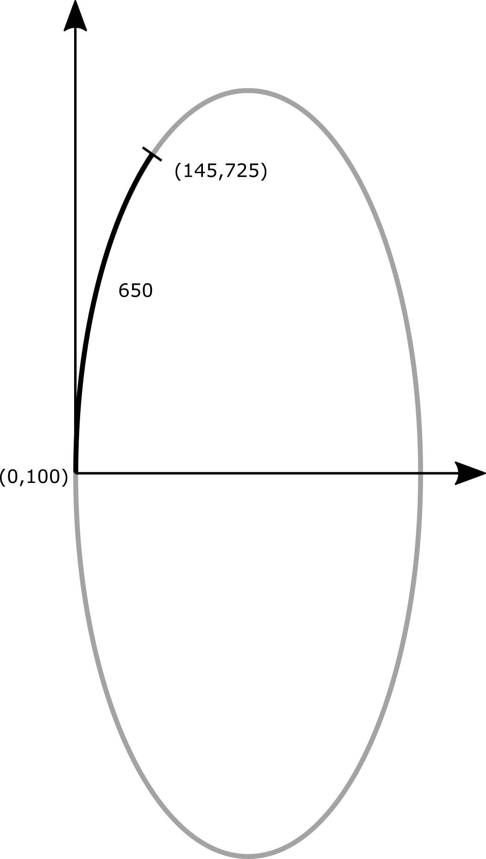
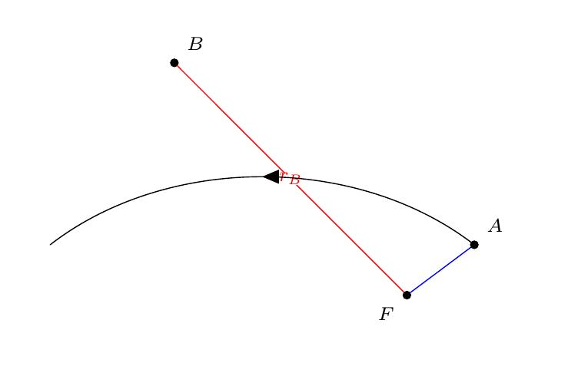
It covers most of the underlying ellipse while remaining open.

3. Half-Elliptical Curve
# Source: AI Source: Provided by: [Data Path: Persons Table -> ID Column: 1, Name_En Column: Motasem Essam] -> From: [ChatGPT] on [7/25/2026]
A Half-Elliptical Curve represents approximately one-half of an ellipse.
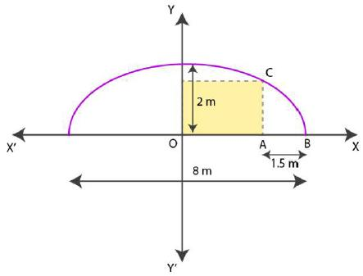
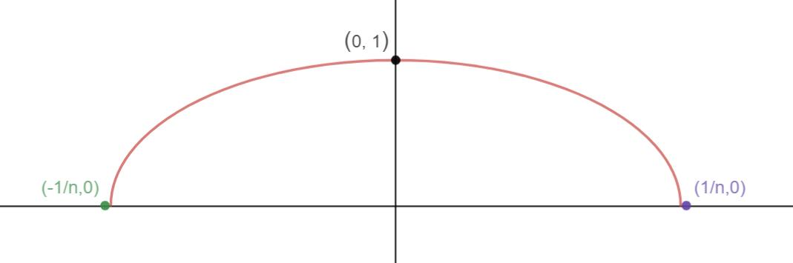
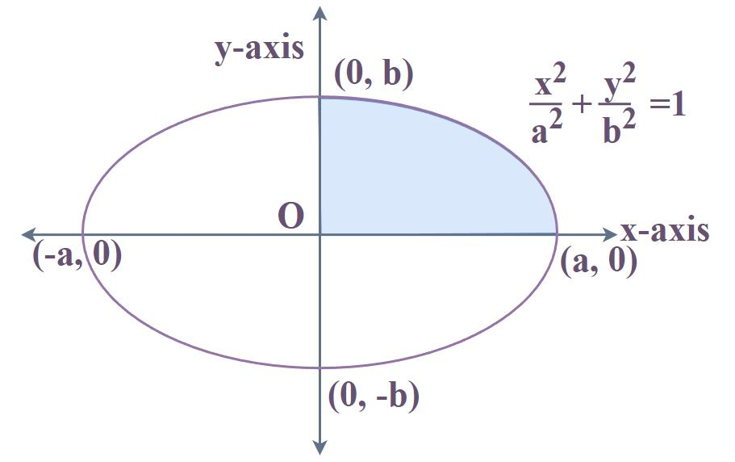
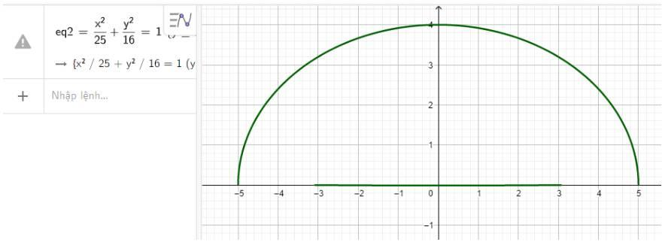
For example, the upper half of an ellipse can be used as an open curved boundary.

4. Quarter-Elliptical Curve
# Source: AI Source: Provided by: [Data Path: Persons Table -> ID Column: 1, Name_En Column: Motasem Essam] -> From: [ChatGPT] on [7/25/2026]
A Quarter-Elliptical Curve represents approximately one-quarter of an ellipse.
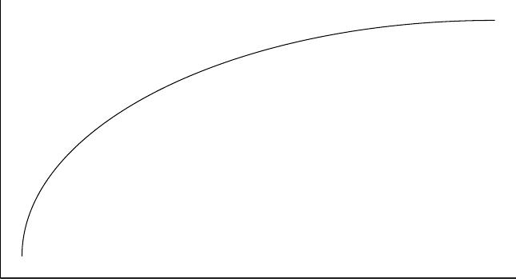
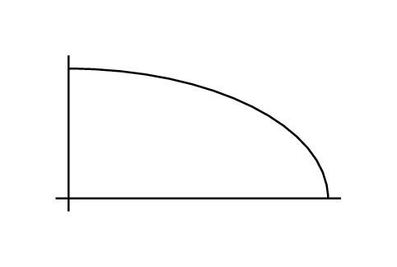
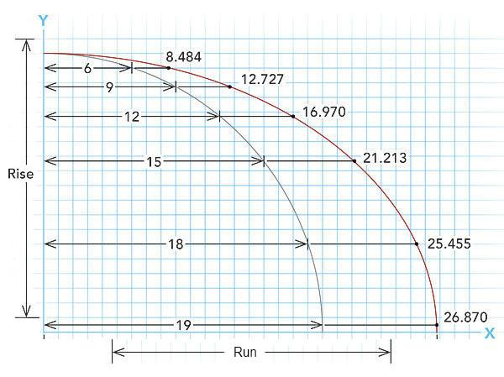
It can be used as a curved corner or as part of a larger composite boundary.

5. Three-Quarter Elliptical Curve
# Source: AI Source: Provided by: [Data Path: Persons Table -> ID Column: 1, Name_En Column: Motasem Essam] -> From: [ChatGPT] on [7/25/2026]
A Three-Quarter Elliptical Curve represents approximately three-quarters of an ellipse while leaving a gap between its endpoints.
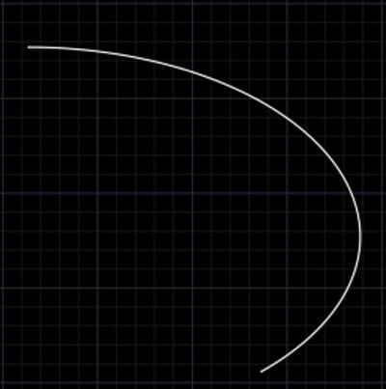
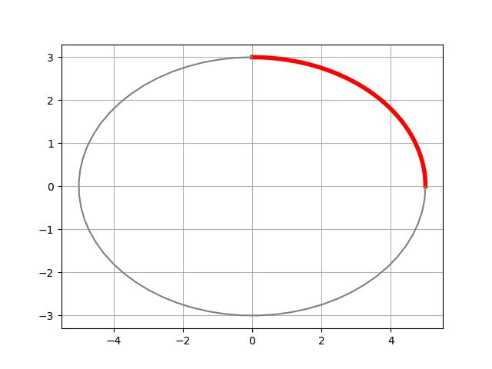
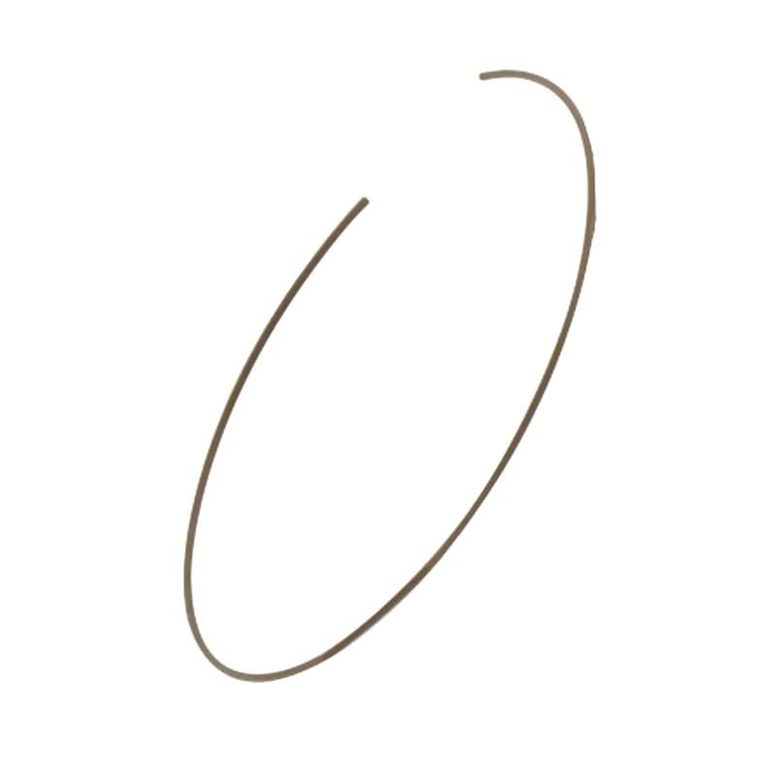

6. Symmetric Open Elliptical Curve
# Source: AI Source: Provided by: [Data Path: Persons Table -> ID Column: 1, Name_En Column: Motasem Essam] -> From: [ChatGPT] on [7/25/2026]
A portion of an ellipse can be arranged symmetrically around one of the ellipse's axes.
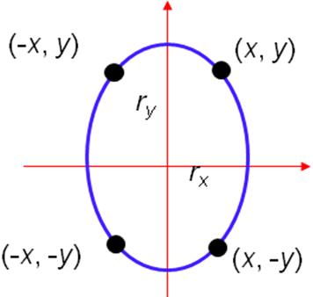
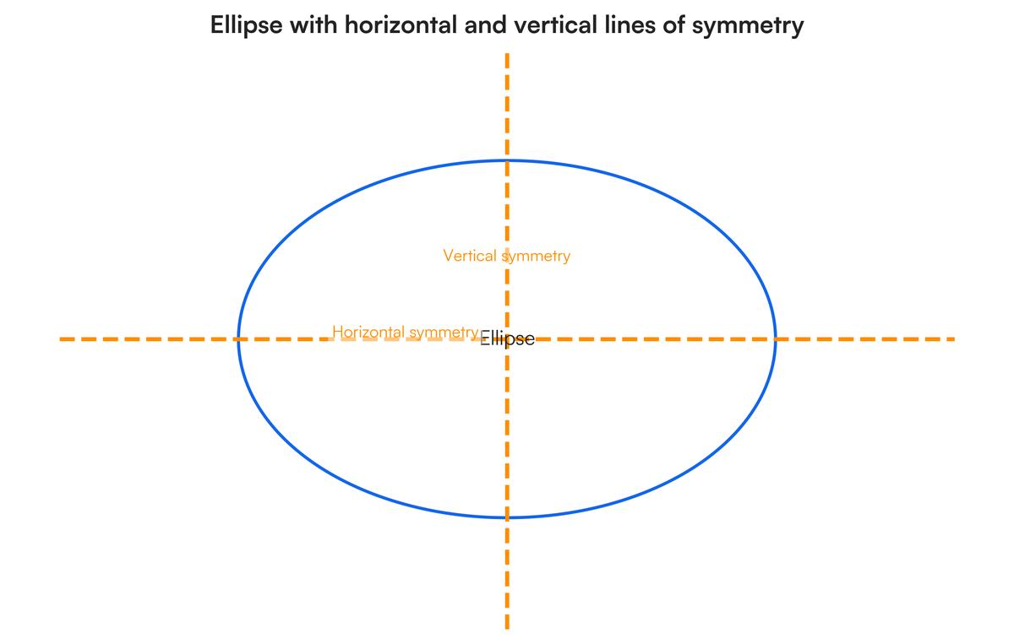
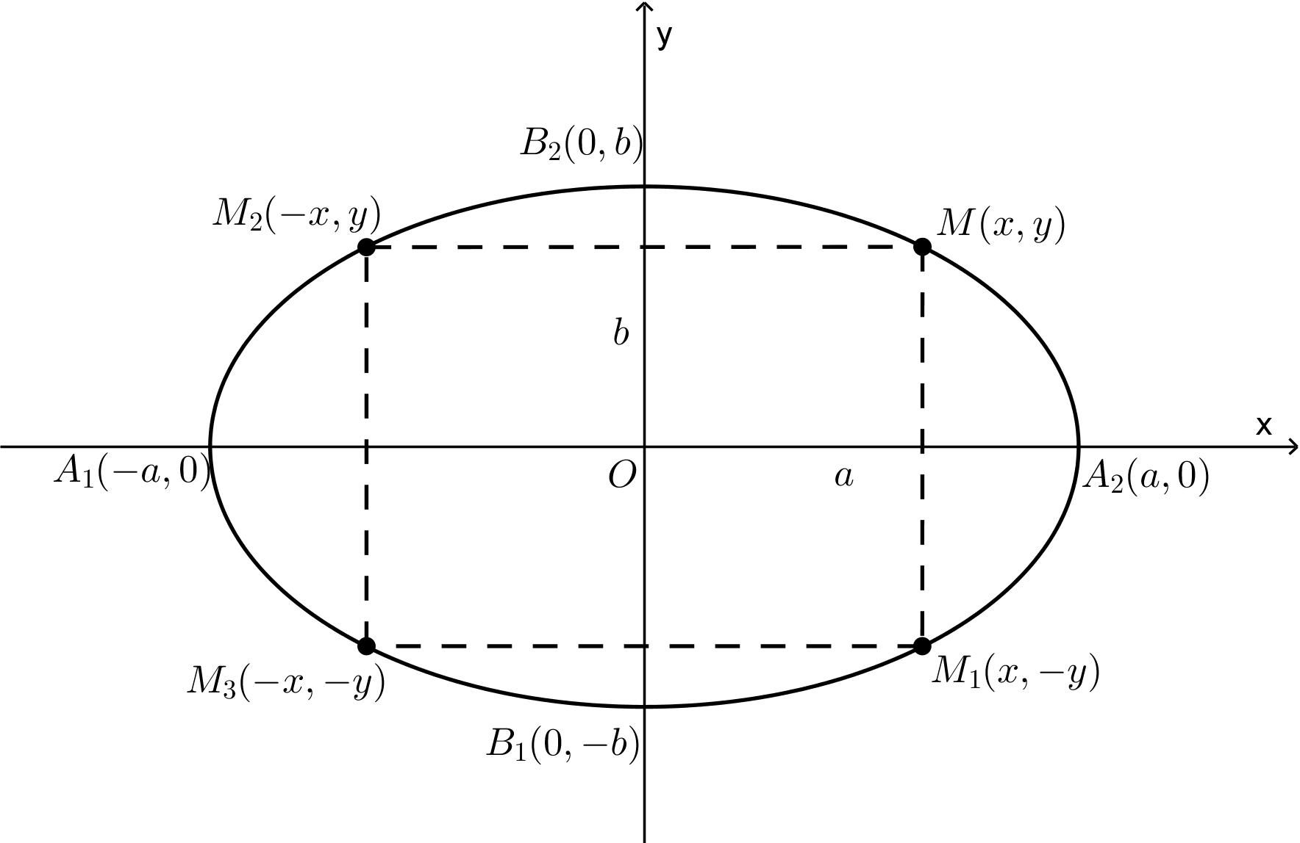
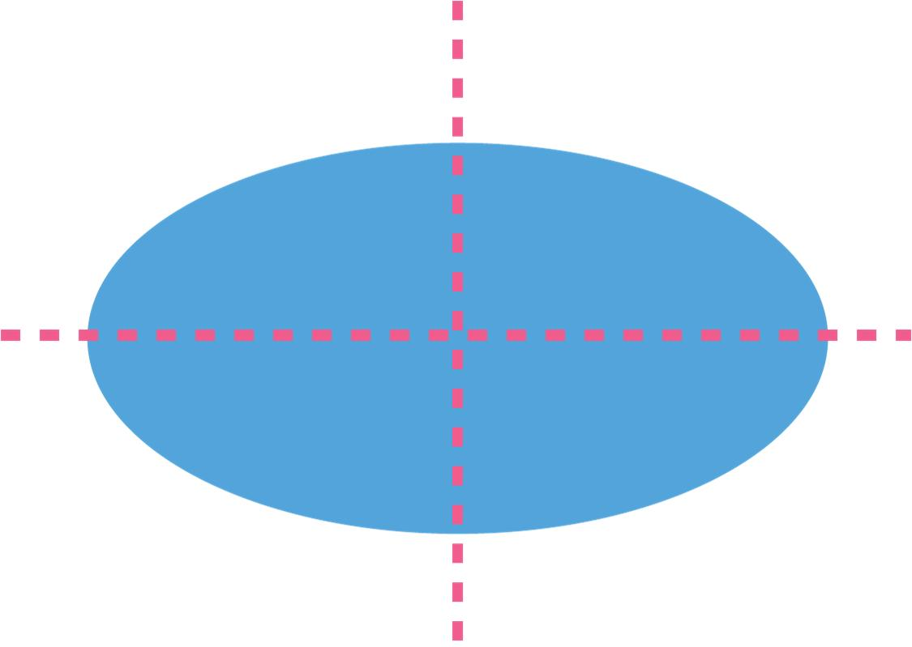
For example, an upper elliptical arc may be symmetric about the vertical major or minor axis, depending on the ellipse's orientation.

7. Asymmetric Open Elliptical Curve
# Source: AI Source: Provided by: [Data Path: Persons Table -> ID Column: 1, Name_En Column: Motasem Essam] -> From: [ChatGPT] on [7/25/2026]
An asymmetric elliptical curve is a selected portion of an ellipse whose endpoints and position do not produce a symmetric appearance.
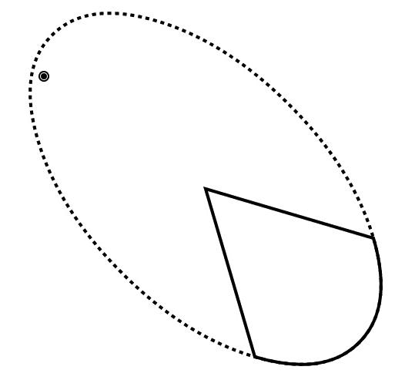
The underlying ellipse can be perfectly regular while the selected open portion appears asymmetric.

8. Upper Open Elliptical Curve
# Source: AI Source: Provided by: [Data Path: Persons Table -> ID Column: 1, Name_En Column: Motasem Essam] -> From: [ChatGPT] on [7/25/2026]
The selected portion follows the upper region of an ellipse.
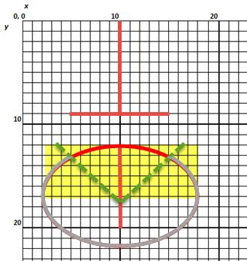
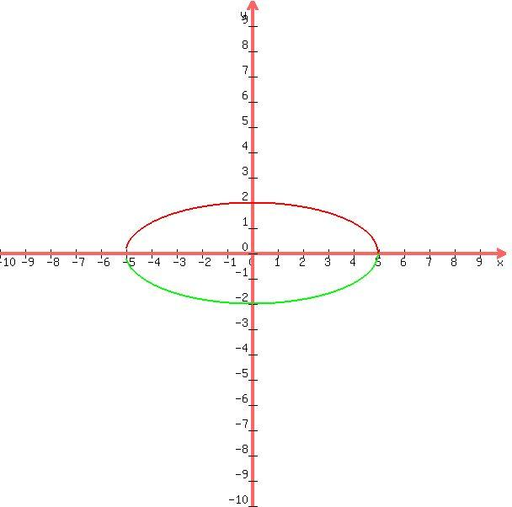
This type is common in arches and curved boundaries.

9. Lower Open Elliptical Curve
# Source: AI Source: Provided by: [Data Path: Persons Table -> ID Column: 1, Name_En Column: Motasem Essam] -> From: [ChatGPT] on [7/25/2026]
The selected portion follows the lower region of an ellipse.
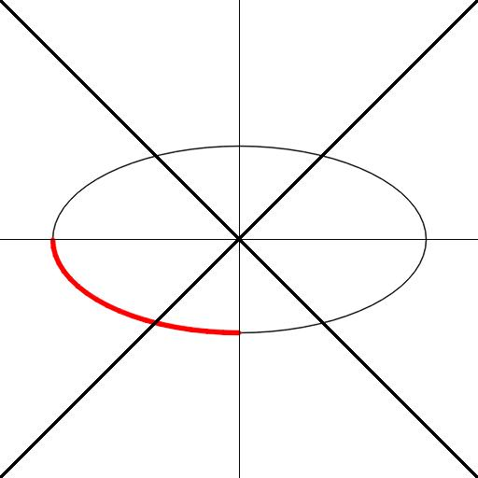

10. Side Open Elliptical Curve
# Source: AI Source: Provided by: [Data Path: Persons Table -> ID Column: 1, Name_En Column: Motasem Essam] -> From: [ChatGPT] on [7/25/2026]
The selected portion follows one side of an ellipse.
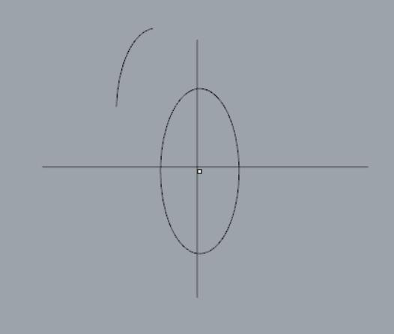
It may follow the left or right portion of the ellipse.

11. Freeform Elliptical Arc
# Source: AI Source: Provided by: [Data Path: Persons Table -> ID Column: 1, Name_En Column: Motasem Essam] -> From: [ChatGPT] on [7/25/2026]
A portion of an ellipse is used as a curved component within a freely designed open shape.
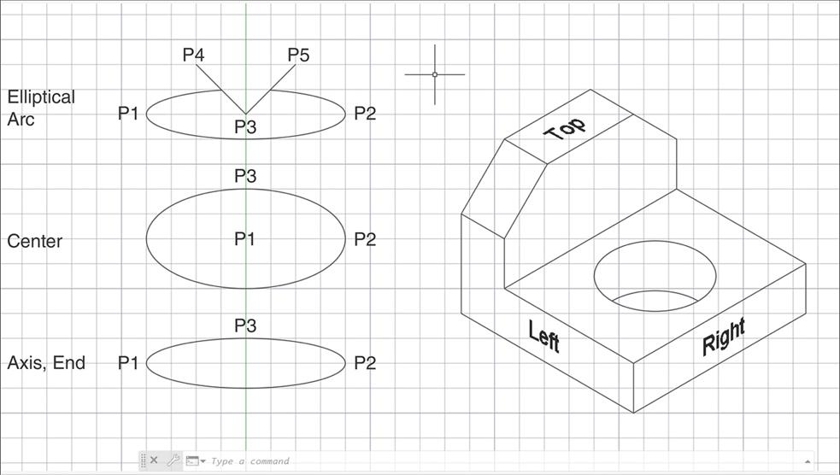
The underlying curve is elliptical, but its placement can be part of a freely designed form.

12. Irregular Open Elliptical Curve
# Source: AI Source: Provided by: [Data Path: Persons Table -> ID Column: 1, Name_En Column: Motasem Essam] -> From: [ChatGPT] on [7/25/2026]
Several elliptical portions or differently oriented elliptical arcs can be combined to create an irregular open curved path.
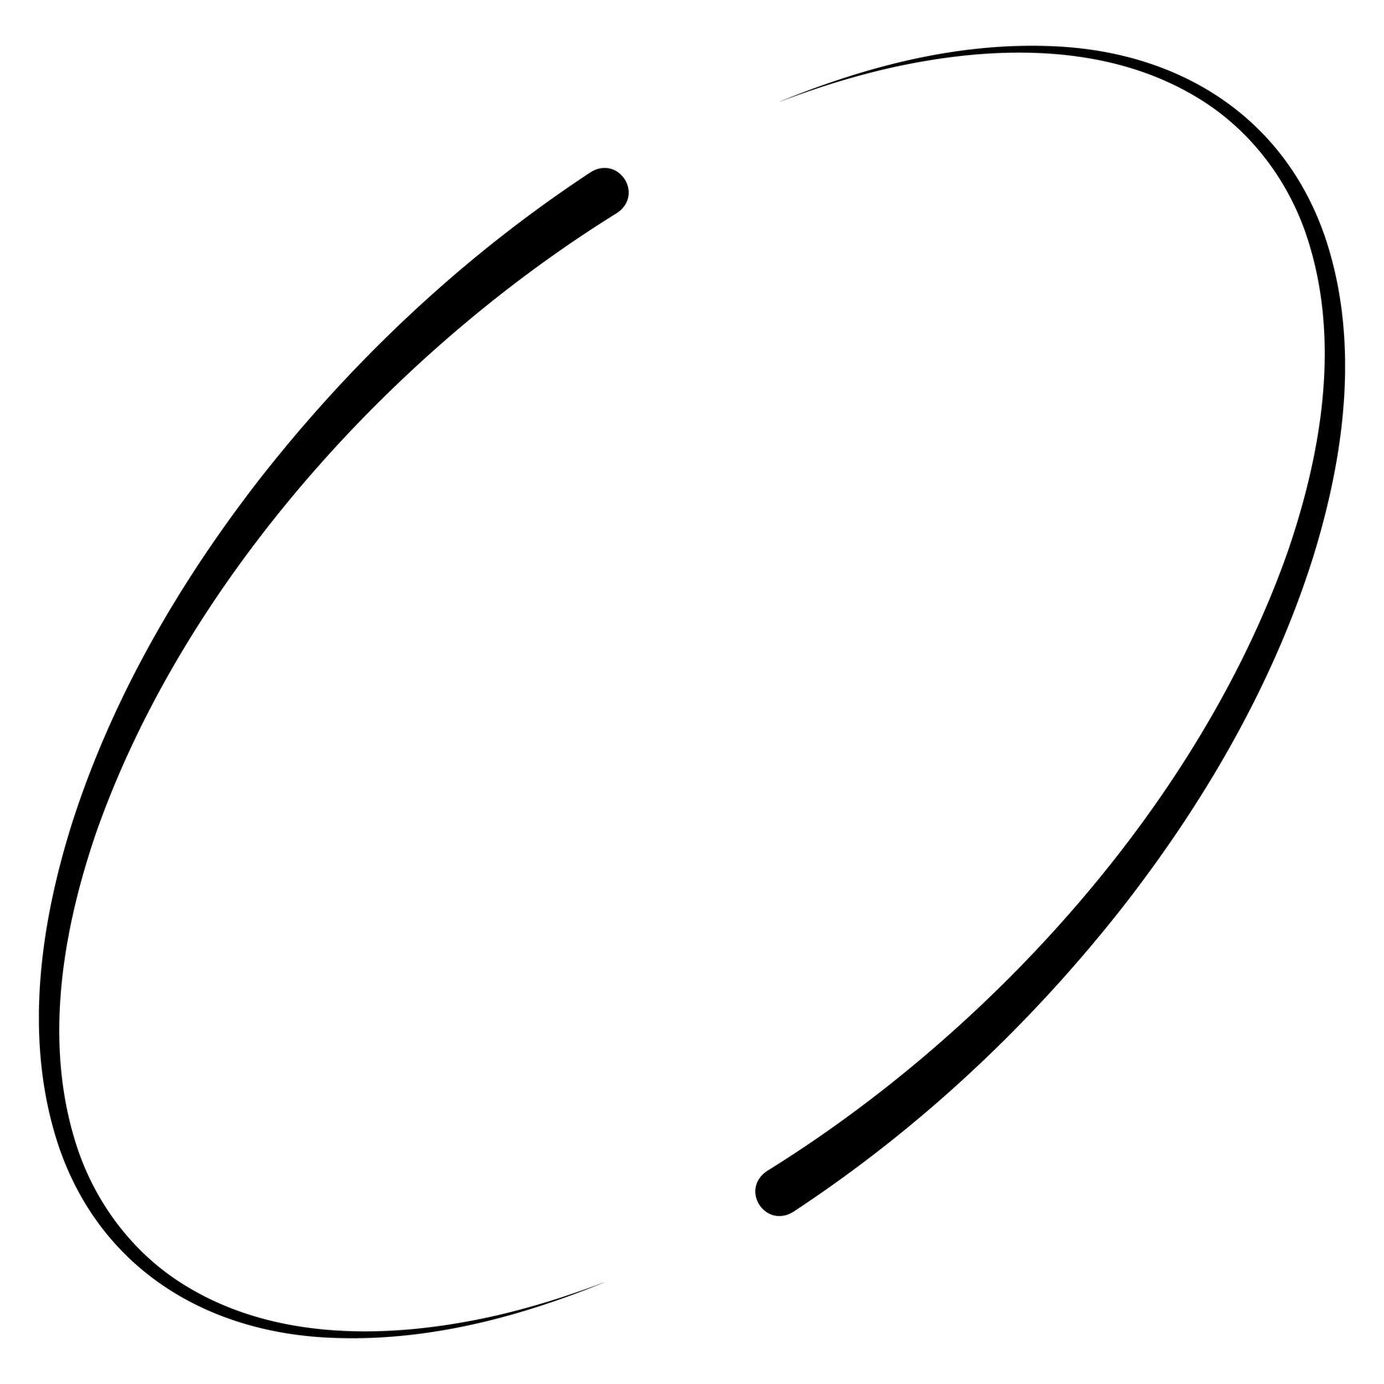
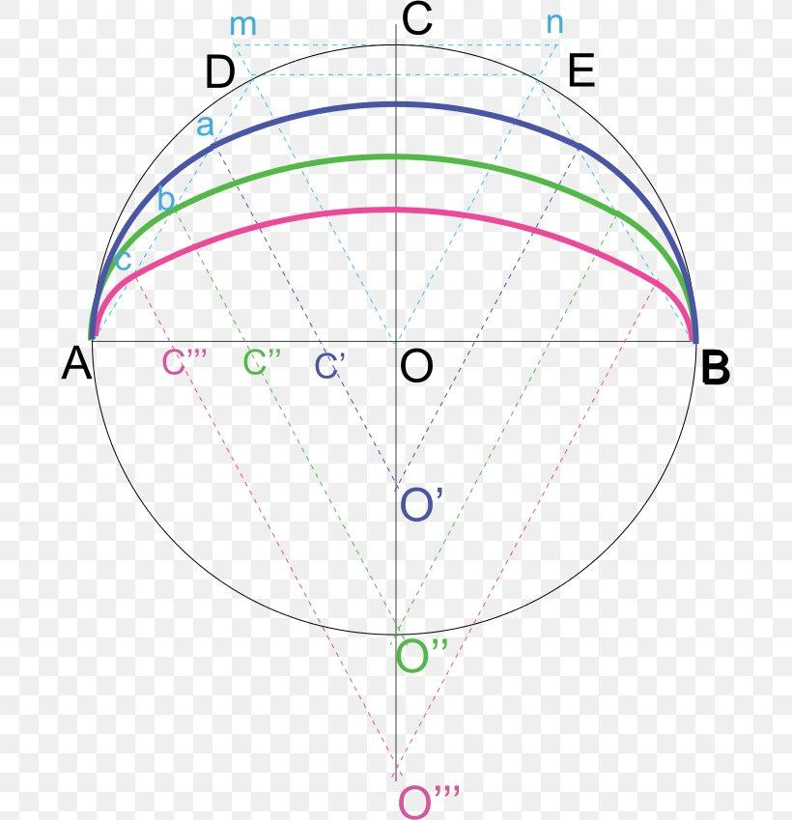
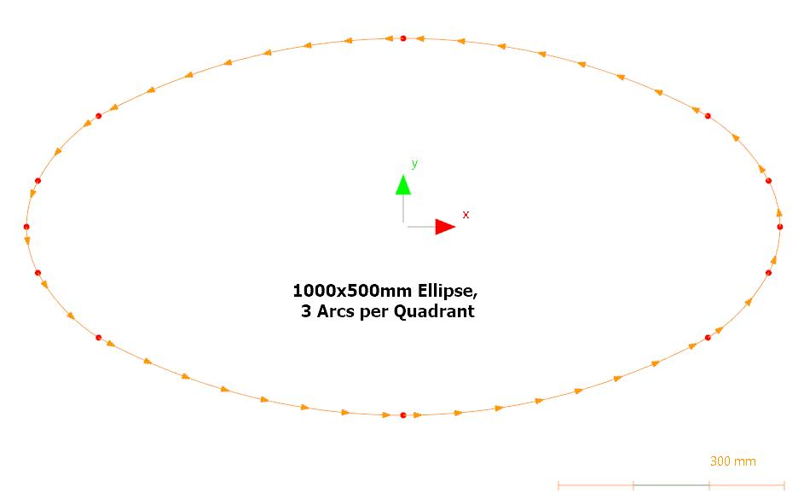
This is useful when classifying more complex open curved forms.

Open Elliptical Curve vs. Complete Ellipse
# Source: AI Source: Provided by: [Data Path: Persons Table -> ID Column: 1, Name_En Column: Motasem Essam] -> From: [ChatGPT] on [7/25/2026]
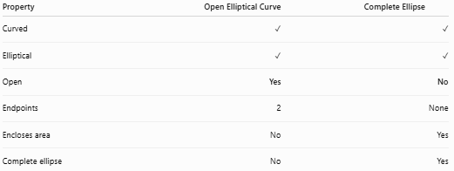
Property | Open Elliptical Curve | Complete Ellipse
Curved | ✓ | ✓
Elliptical | ✓ | ✓
Open | Yes | No
Endpoints | 2 | None
Encloses area | No | Yes
Complete ellipse | No | Yes
The defining difference is closure.

Arc Length
# Source: AI Source: Provided by: [Data Path: Persons Table -> ID Column: 1, Name_En Column: Motasem Essam] -> From: [ChatGPT] on [7/25/2026]
For an ellipse with semi-major axis (a) and semi-minor axis (b), the length of an arbitrary elliptical arc generally does not have a simple elementary formula.
The complete ellipse circumference itself is commonly approximated by formulas such as:
[
$$C≈π\left[3\left(a+b\right)-\sqrt{\left(3a+b\right)\left(a+3b\right)}\right]$$]
For a specific elliptical arc, numerical methods are generally used.

Key Points
# Source: AI Source: Provided by: [Data Path: Persons Table -> ID Column: 1, Name_En Column: Motasem Essam] -> From: [ChatGPT] on [7/25/2026]
An Open Elliptical Curve is:
$$\boxed{\text{Open}+\text{Part of an Ellipse}+\text{Two Endpoints}}$$
It:
- Is a portion of an ellipse rather than a complete ellipse.
- Has two distinct endpoints.
- Has continuously changing curvature.
- Does not enclose an area by itself.
- Can be short, long, half-elliptical, quarter-elliptical, or three-quarter elliptical.
- Can be symmetric or asymmetric.
- Can form part of a larger composite shape.
- Generally requires numerical methods when calculating an arbitrary arc length.
Most important distinction
$$\boxed{\text{Open Elliptical Curve}≠\text{Complete Ellipse}}$$
An open elliptical curve is only a portion of the ellipse, while a complete ellipse is a closed curve.

Conclusion
# Source: AI Source: Provided by: [Data Path: Persons Table -> ID Column: 1, Name_En Column: Motasem Essam] -> From: [ChatGPT] on [7/25/2026]
Open Elliptical Curves are open portions of an ellipse characterized by continuous elliptical curvature and two unconnected endpoints. They can be classified according to their extent, position, symmetry, and role within a larger shape.

